**7DAILY ONLINE ACTIVITIES SUMMARY**

|  |  |  |  |  |  |  |  |  |
| --- | --- | --- | --- | --- | --- | --- | --- | --- |
| **Date:** | **5-6-2020** | | | | | **Name:** | **Prajna** | |
| **Sem & Sec** | **8th sem ‘B’** | | | | | **USN:** | **4AL16CS067** | |
| **Online Test Summary** | | | | | | | | |
| **Subject** | | **BDA** | | | | | | |
| **Max. Marks** | | **30** | | **Score** | | | **29** | |
| **Certification Course Summary** | | | | | | | | |
| **Course** | **Introduction to front end** | | | | | | | |
| **Certificate Provider** | | | **Great Learning** | | **Duration** | | | **30min** |
| **Coding Challenges** | | | | | | | | |
| **Problem Statement:**1**.** Write a c program to print triangle pattern. | | | | | | | | |
| **Status: Completed** | | | | | | | | |
| **Uploaded the report in GitHub**  **GitHub link:** | | | | | **Yes**  **https://github.com/alvas-education-foundation/prajna_k** | | | |
| **If yes Repository name** | | | | | **prajna_k** | | | |
| **Uploaded the report in slack** | | | | | **yes** | | | |

Online Test Details: (Attach the snapshot and briefly write the report for the same)

Certification Course Details: (Attach the snapshot and briefly write the report for the same)

Coding Challenges Details: (Attach the snapshot and briefly write the report for the same)

1)online test

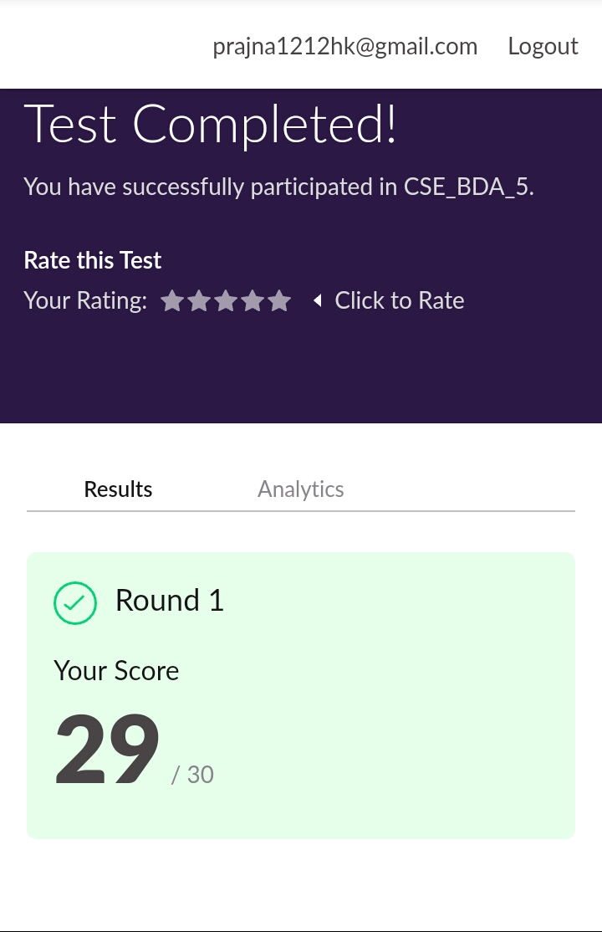

2) certification course

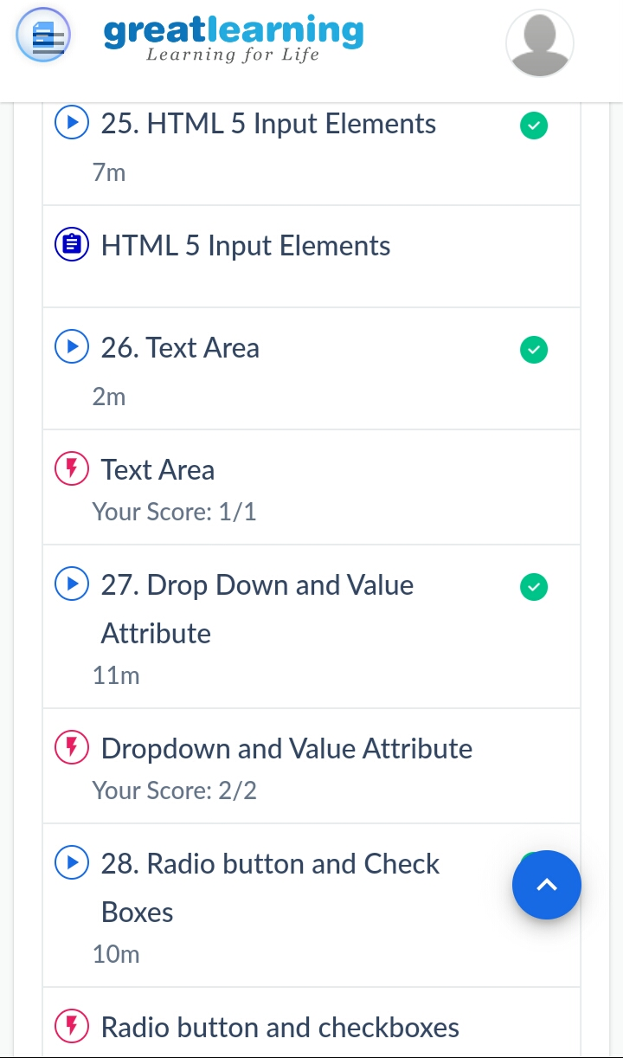

3) coding challenges

Program 1

|  |
| --- |
|  |

#include <stdio.h>

int main() {

int rows,i,j;

printf("Enter the number of rows : ");

scanf("%d",&rows);

for (i = 0; i < rows; i++){

for (j = rows; j > i; j--){

printf(" ");

}

for (int k = 1; k <= i + 1; k++) {

printf(" *");

}

printf("\n");

}

return 0;

}

|  |
| --- |
|  |
|  |  |
|  |  |
|  |  |
|  |  |
|  |  |